Computer Programming Laboratory | 
Laboratory 4: Making Decision Part1 | School of Information Technology
Name: Thu rein Oo | ID: 6731501110 | Section: 3

Course Learning Outcomes (CLO)
- CLO1.1: Students do their own work, do not present the work of others as their own, do not cheat on exams, and are responsible for completing their work.
- CLO2.3: Students understand the principles of programming including emerging technology, and how to utilize them together.
- CLO6.1: Students are able to complete their assigned work for each particular concept.

Lesson Learning Outcomes (LLOs)
- LLO1: Understand the concept of if … else statements in C# for making decisions based on conditions [Aligns with CLO2.3].

Lab Objectives
- Develop programs to use if … else statements to check conditions and execute appropriate code blocks [Aligns with CLO2.3 and CLO6.1].

Remark:
- CLO → LLO → Lab Objectives
- Students are expected to complete the lab on their own, with no plagiarism or cheating [Aligns with CLO1.1].

Instruction:
- Complete and answer all required questions: In-class (Questions 1-2) and Homework (Question 1)

Submission:
- Save this document file that contains all required answers as “Lab04_YourID.pdf” and submit it to the MFU LMS system by the deadline.

💎Learn more (Self-study): https://www.w3schools.com/cs/cs_conditions.php

Remark:
- Not accept late submission!!!

[In-class] Question 1
From the given flowchart, write a program to enter a number (integer) and show that this number is negative OR zero OR positive.

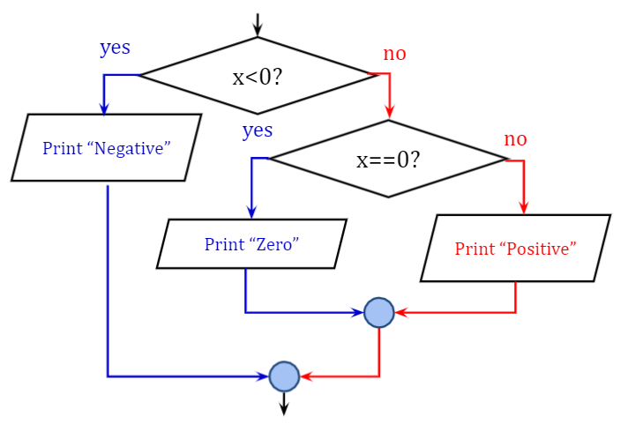
Expected results
Example1 | Example2 | Example3
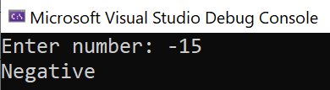 | 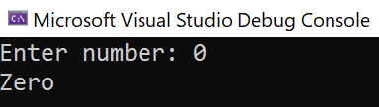 | 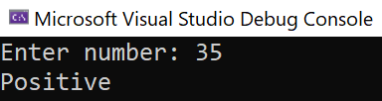

Answer: source code
using System;

class Program
{
static void Main()
{
// Input an integer from the user
Console.Write("Enter number: ");
int x = int.Parse(Console.ReadLine());

// Check the conditions according to the flowchart
if (x < 0)
{
Console.WriteLine("Negative");
}
else if (x == 0)
{
Console.WriteLine("Zero");
}
else
{
Console.WriteLine("Positive");
}
}
}

[In-class] Question 2
Write a program that allows a user to input two floating-point numbers, compare them, and show the result of the comparison as the expected results.

Expected results
Example1

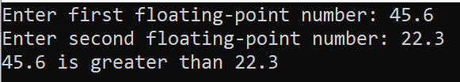
Example2

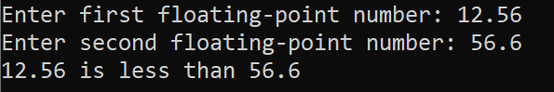
Example3

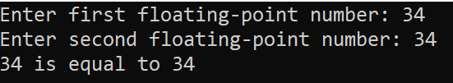

Answer: source code
using System;

class Program
{
static void Main()
{
// Input two floating-point numbers from the user
Console.Write("Enter first floating-point number: ");
float num1 = float.Parse(Console.ReadLine());

Console.Write("Enter second floating-point number: ");
float num2 = float.Parse(Console.ReadLine());

// Compare the two numbers
if (num1 > num2)
{
Console.WriteLine($"{num1} is greater than {num2}");
}
else if (num1 < num2)
{
Console.WriteLine($"{num1} is less than {num2}");
}
else
{
Console.WriteLine($"{num1} is equal to {num2}");
}
}
}

[Homework] Question 1
Write a program to ask a user to
- Enter total score / overall score
- Check its grade according to the table below.
- Check if the total score must be greater than or equal to 0 and less than or equal to 100.

Remark: After checking, please show the result of checking as the expected results.

Total score | Grade
80-100 | A
75-79 | B+
70-74 | B
65-69 | C+
60-64 | C
55-59 | D+
50-54 | D
0-49 | F

Expected Results
Example1

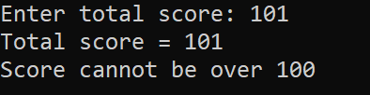
Example2

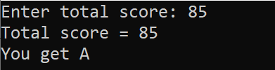
Example3

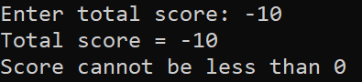

Answer: source code
using System;

class Program
{
static void Main()
{
Console.Write("Enter total score: ");
int totalScore = int.Parse(Console.ReadLine());

if (totalScore > 100)
{
Console.WriteLine("Total score = " + totalScore);
Console.WriteLine("Score cannot be over 100");
}
else if (totalScore < 0)
{
Console.WriteLine("Total score = " + totalScore);
Console.WriteLine("Score cannot be less than 0");
}
else
{
Console.WriteLine("Total score = " + totalScore);
string grade;

if (totalScore >= 80)
grade = "A";
else if (totalScore >= 75)
grade = "B+";
else if (totalScore >= 70)
grade = "B";
else if (totalScore >= 65)
grade = "C+";
else if (totalScore >= 60)
grade = "C";
else if (totalScore >= 55)
grade = "D+";
else if (totalScore >= 50)
grade = "D";
else
grade = "F";

Console.WriteLine("You get " + grade);
}
}
}

[Optional Question – Challenge] - This part is not required for completion and submission.

Question #1:
Write a program to take three floating-point numbers from the user and then print the greatest number.
Hint: You can use Logical and (&&) to join multiple clauses/conditions of an “if” / “else if” statement.

Expected result
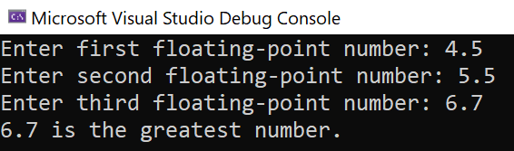

Answer: source code
using System;

class Program
{
static void Main()
{
// Input three floating-point numbers from the user
Console.Write("Enter first floating-point number: ");
float num1 = float.Parse(Console.ReadLine());

Console.Write("Enter second floating-point number: ");
float num2 = float.Parse(Console.ReadLine());

Console.Write("Enter third floating-point number: ");
float num3 = float.Parse(Console.ReadLine());

// Determine the greatest number
float greatest;

if (num1 >= num2 && num1 >= num3)
{
greatest = num1;
}
else if (num2 >= num1 && num2 >= num3)
{
greatest = num2;
}
else
{
greatest = num3;
}

// Output the greatest number
Console.WriteLine($"{greatest} is the greatest number.");
}
}

💎Learn more (Self-study): https://www.w3schools.com/cs/cs_conditions.php

